Task 1
Construct the automata machines for any five of the following given conditions of regular expressions:
- Contain the substring (a+b)*abba(a+b)*:

R.E=(a+b)*abba(a+b)*
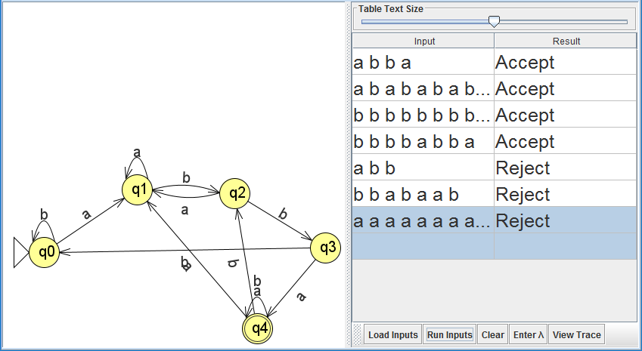
- Doesn’t conatin the substring R.E=(bba|ba|a*)*(a*|b|bb):

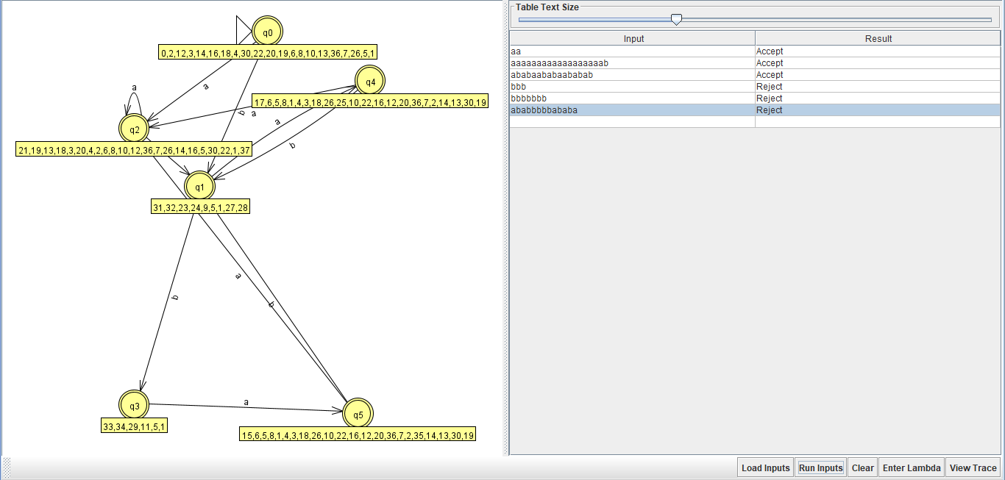

- Fifth-to-last symbol is a:
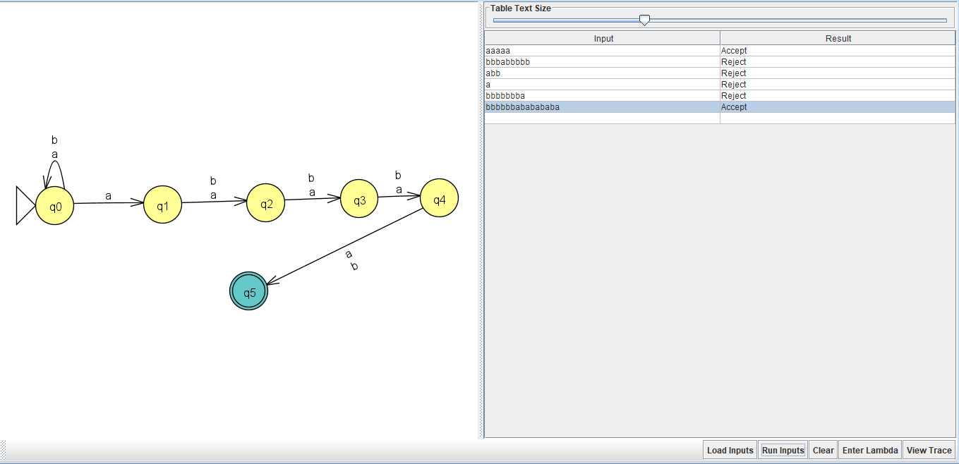
- Decimal Digits:
Positive ternary Number:
R.E= (1|2)(0|1|2)*
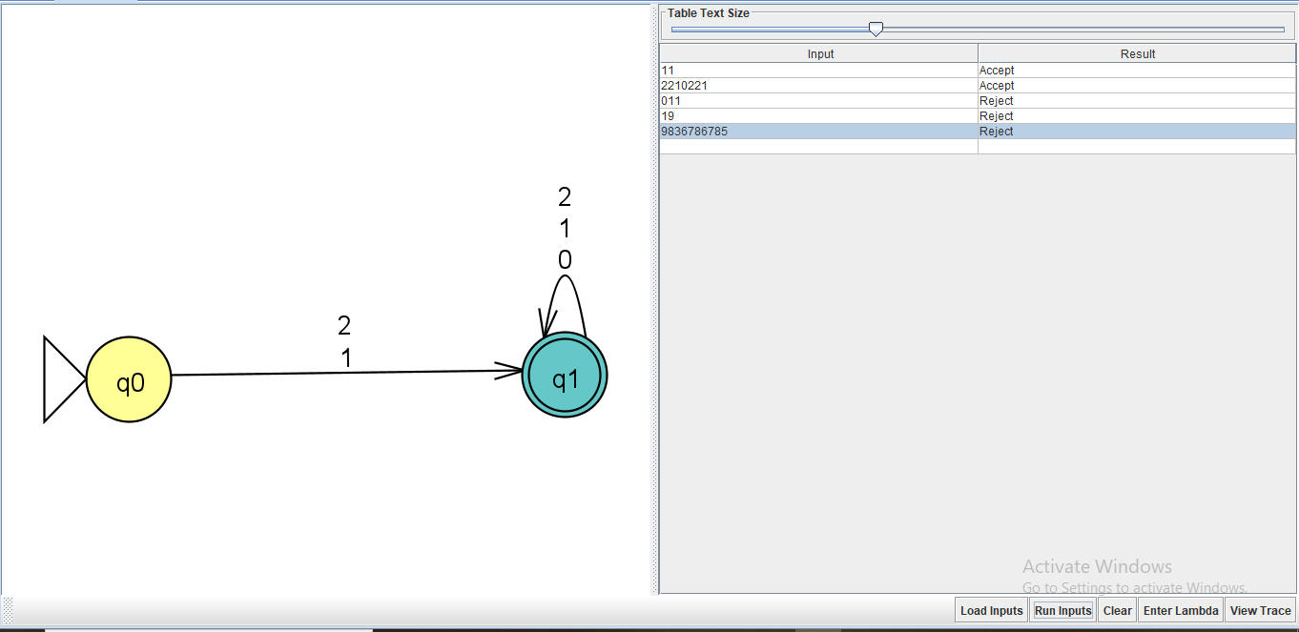
5) Positive Integer Divisible By 5:
R.E: (5|1-9)(0-9)*(0|5)
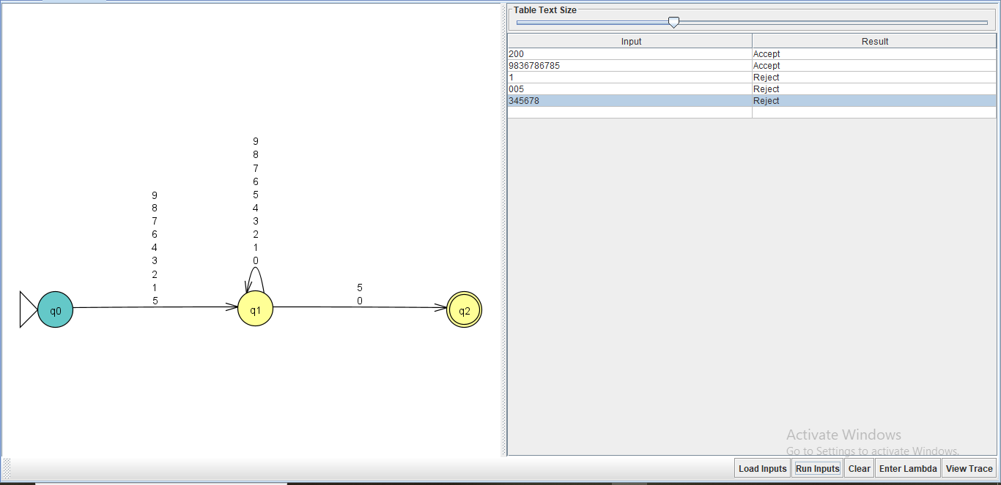

4. Homework Tasks:

2. Use JFLAP to prove that the above regular expressions are valid.
3. Write a code to check any four regular expressions that are defined in question 1. Generate the right and wrong answer or validate the correct or incorrect input
Combine 2 and 3 :

1) Second-last symbol is a :
R.E is = (a+b)*a(a+b)
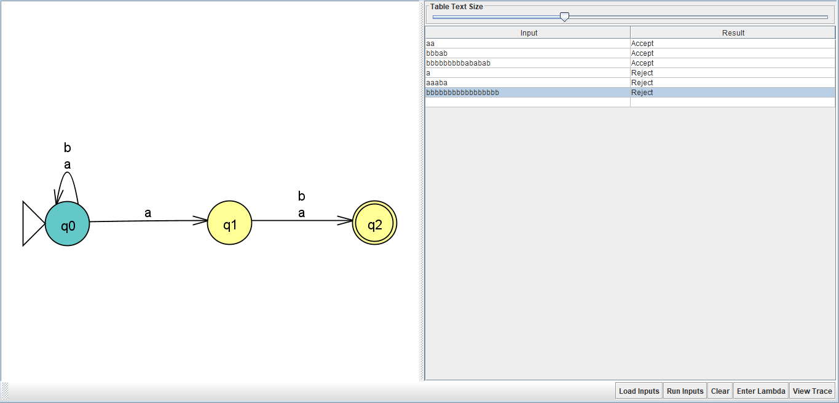
Accepted string is =aa,bbbab,bbbbbbbbbbbbabb
Rejected string is = a,aaaba, bbbbbbbbbbbb

2) Equal Number of a’s and b’s:
R.E = (ab)+
3) Containing the Pattern abba:
R.E = (a+b)*abba
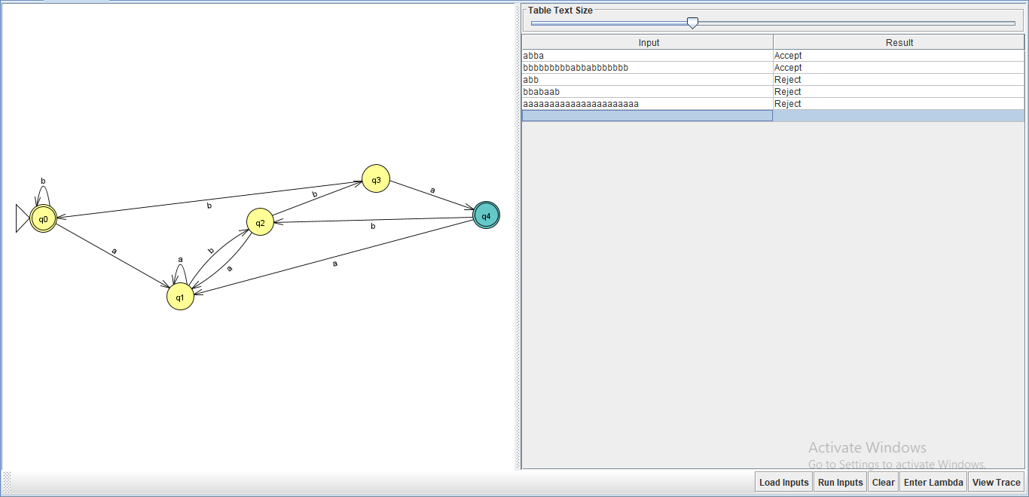
Accepted String : abba, bbbbbbbbbabbabbbbbbb
Rejected String : abb, bbabaab, aaaaaaaaaaaaaaaaaaaaaa
4) Palindromes:
R.E = ((a)*ba)*
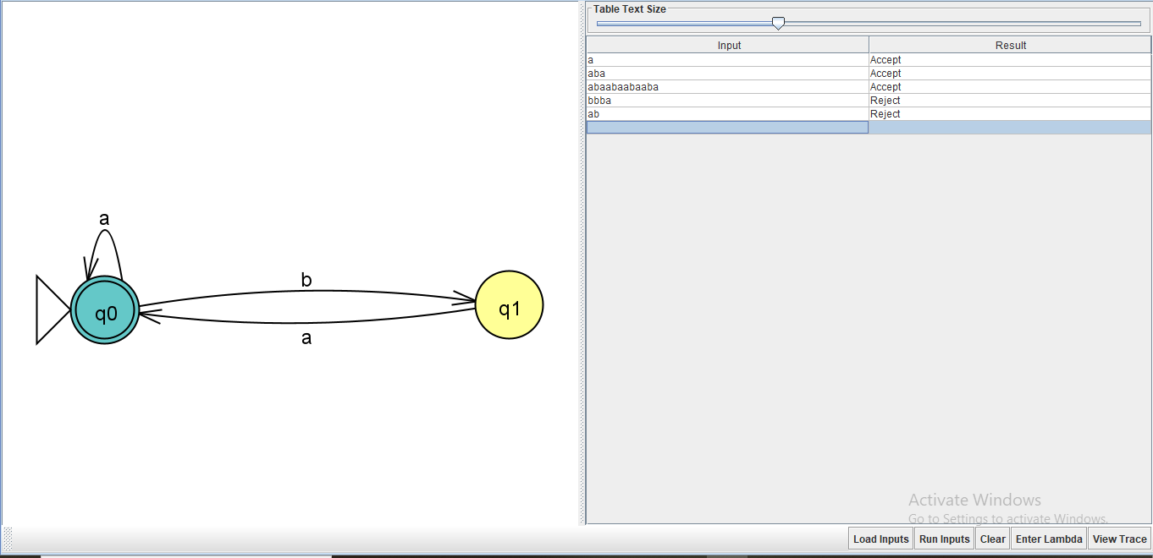
5) Number of b’s Divisible by 3:
R.E= ((a)*b(a)*b(a)*b)*
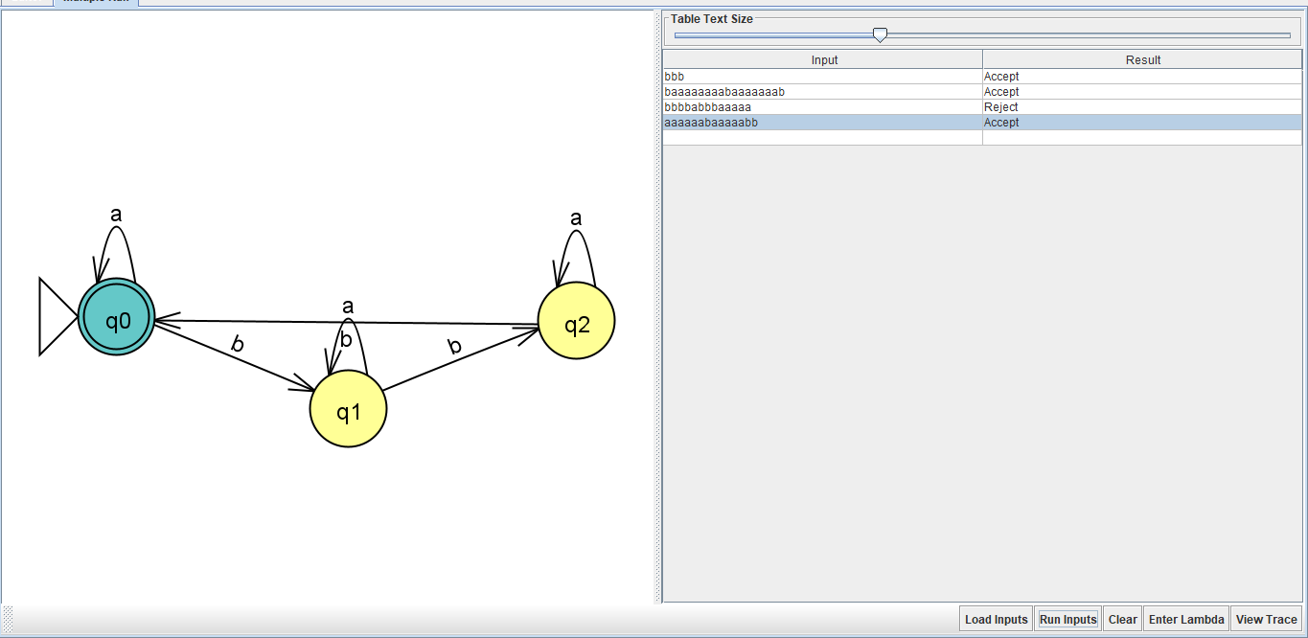

6) U.S Telephone Number :
R.E = ((8+6)0(0+1+2+3+4+5+6+7+8+9))(0+1+2+3+4+5+6+7+8+9)(0+1+2+3+4+5+6+7+8+9)(0+1+2+3+4+5+6+7+8+9)(0+1+2+3+4+5+6+7+8+9)(0+1+2+3+4+5+6+7+8+9)(0+1+2+3+4+5+6+7+8+9)(0+1+2+3+4+5+6+7+8+9)
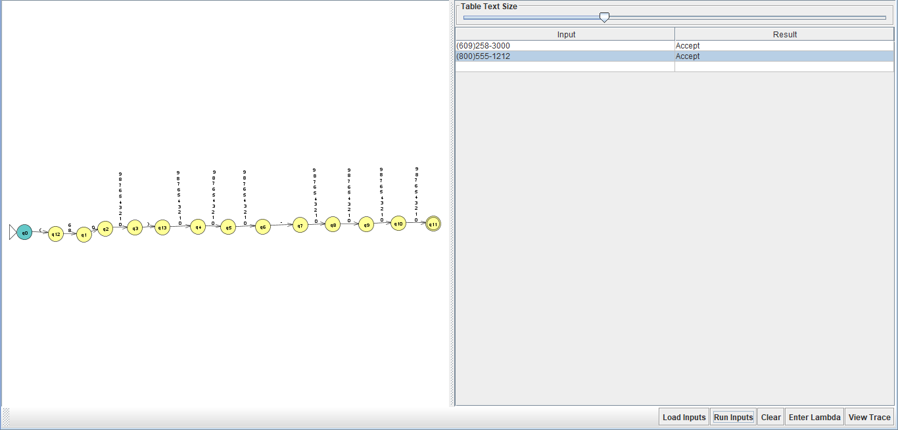
7) Amino Acid:
R.E : A(G+T+C+A)(C+A)+T(G+T+C+A)A+C(G+T+C+A)A+G(G+T+C+A)A
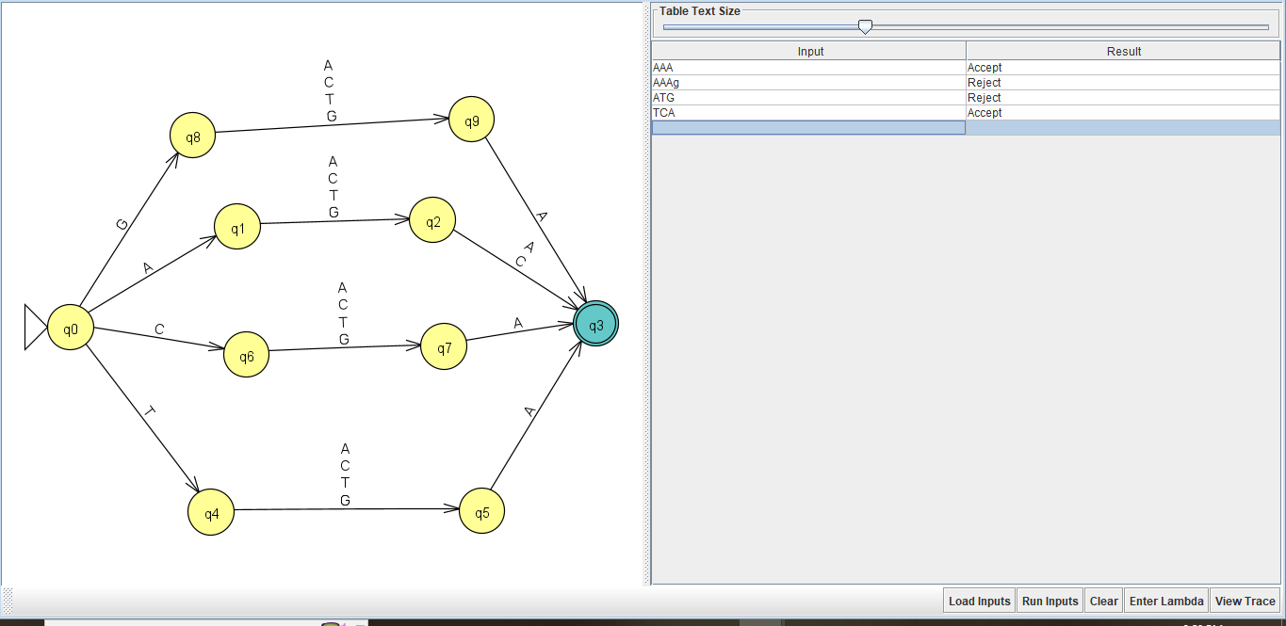
Old Integers:
R.E: ((0+2+4+6+8)*(1+3+5+7+9)(1+3+5+7+9)*(0+2+4+6+8))*(0+2+4+6+8)*(1+3+5+7+9)(1+3+5+7+9)*
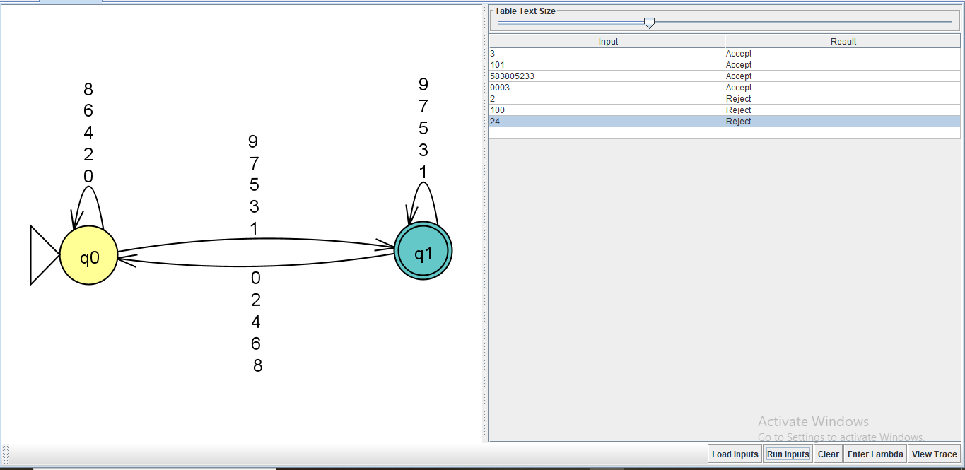
Code to verify the string is valid or not
1) Containing the Pattern abba:
R.E=(a+b)*abba
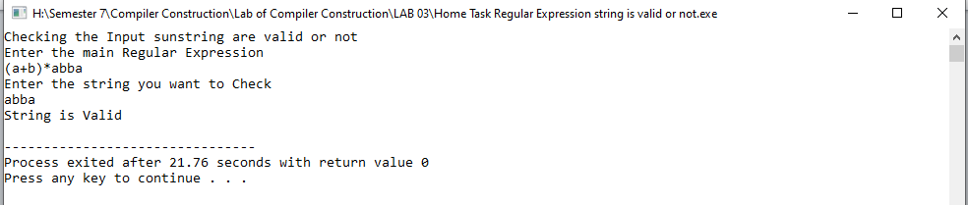
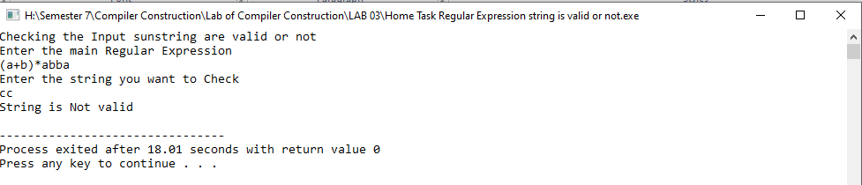
2) Second-last symbol is a :
R.E is = (a+b)*a(a+b)
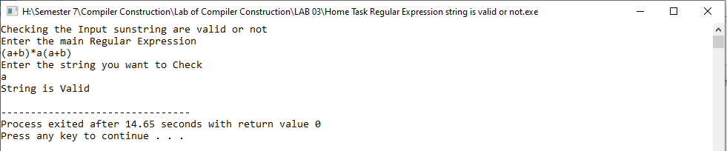
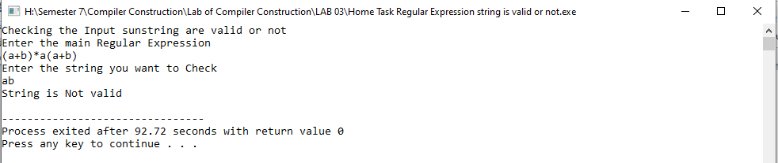
3) Number of b’s Divisible by 3:
R.E= ((a)*b(a)*b(a)*b)*
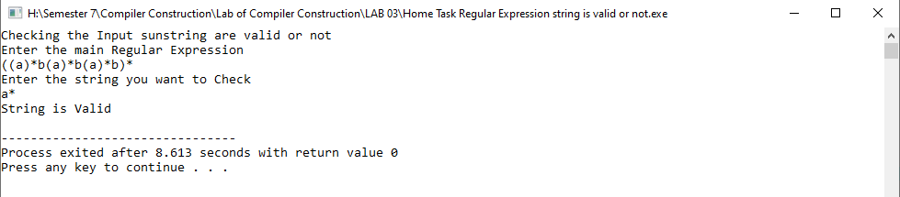

4. For the following FA’s find the regular expression and use regex to code.

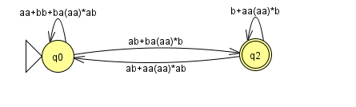
R.E=((aa+bb+ba(aa)*ab)*(ab+ba(aa)*b)(b+aa(aa)*b)*(ab+aa(aa)*ab))*(aa+bb+ba(aa)*ab)*(ab+ba(aa)*b)(b+aa(aa)*b)*
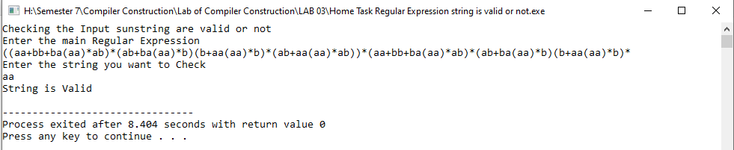
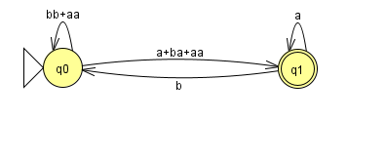R.E=((bb+aa)*(a+ba+aa)a*b)*(bb+aa)*(a+ba+aa)a*
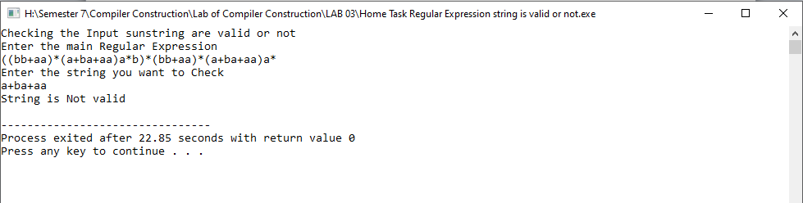

Lab Task :
Program to use regex_search() for finding the pattern in a given string with other parameters.
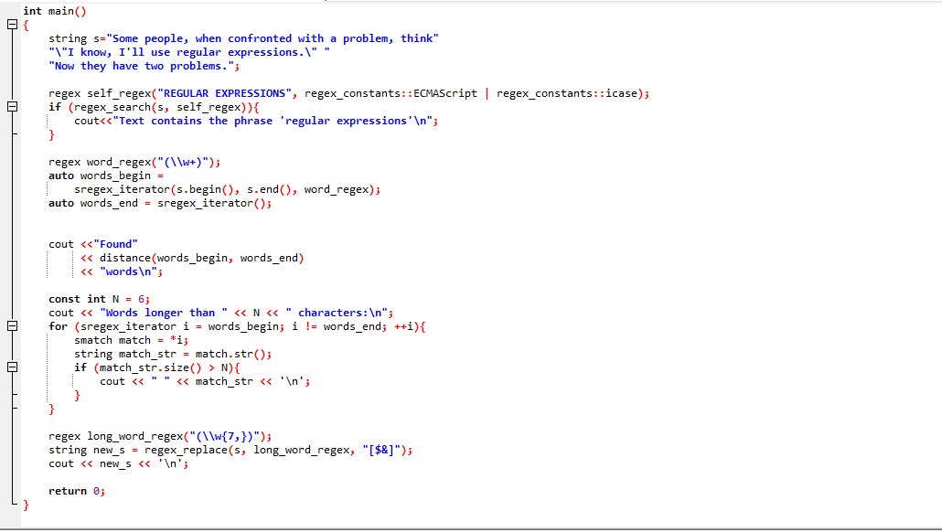
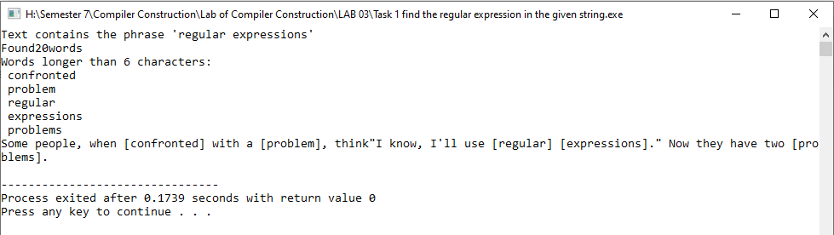

- i. Write your observations after executing this piece of code.
- ii. What is the purpose of using [$&], \\w{7, } and \\w+.
- Find total word in the sentences and find the length of each word and return those word whose length is greater than 6 character.
- [$&] used for making starting and ending of the string.\\w{7,} marking those word which has length 7 and above of it. \\w+ for checking the word.

Program to demonstrate the working of regex_match() for a given string.
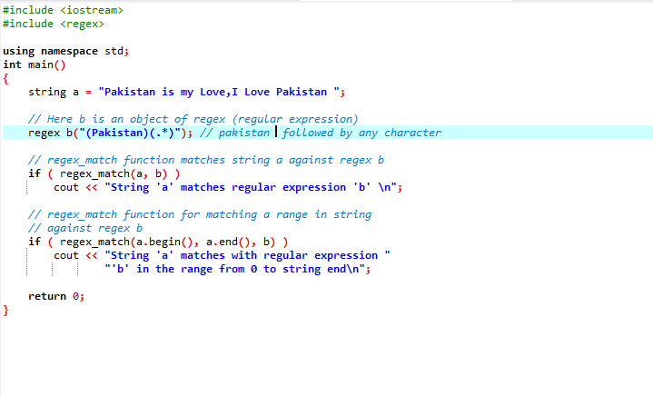
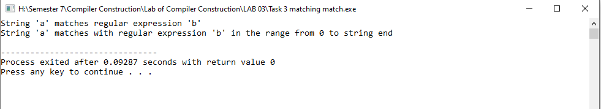
After executing the above code, answer the followings:
- i. What is the purpose of using regex_match?
- ii. What is the purpose of using a.begin() and a.end() in this code?
Answer:
- Regex_match purpose to check the existing word is present in the string or not
- A.begin() check the first word and a.end() check the end word of the string.

Program of using regex_replace()
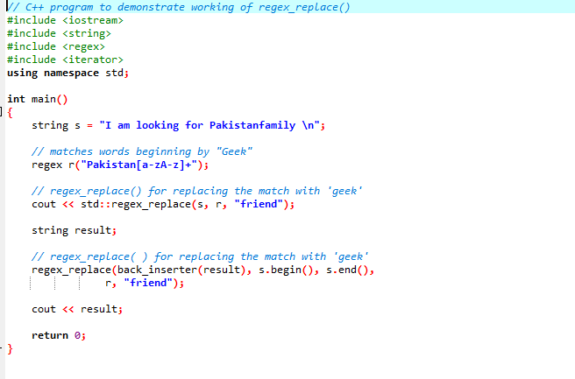
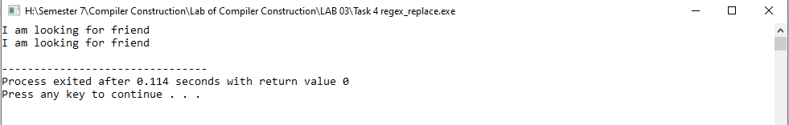
Another C++ program to demonstrate the regex_replace() function.
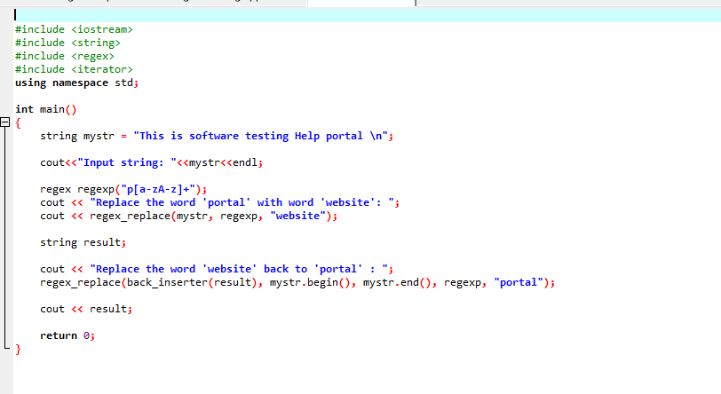
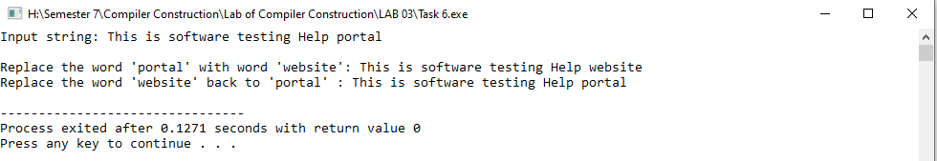
Program to demonstrate the validation of incoming data.
